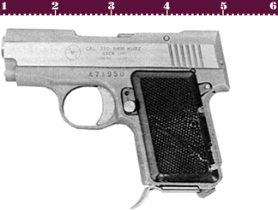
AMT .380 Backup
Ammo | Mag | Rng | ROF | Dam | Arm
.380 ACP  .45 ACP | 8  5 | 5  5 | 2  2 | 1  2 | X3  x3
AMT .380 Backup: A small lightweight pistol designed to be carried concealed as a backup weapon. Not much good for anything other than short range combat, but with a length at just over 4 inches who cares.
Nation: United States Weight: .475 kg
Ammunition: .380 ACP .45 ACP Magazine: 8 / 5
Price: $230 Availability: ( R/S )

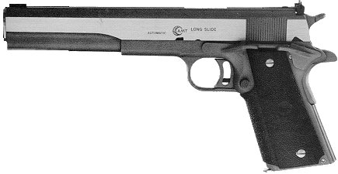
AMT Hardballer
Ammo | Mag | Rng | ROF | Dam | Arm
.45 ACP  .45 ACP* | 8  8 | 10  15 | 2  2 | 2  2 | x3  x3
AMT Hardballer: A stainless steel version of the standard US Army .45 Automatic. The Hardballer is an exceptionally well-made weapon. A special version called the “Longslide” (shown above and stats marked with an ‘*’) was the pistol used by Arnold Schwarzenegger in the movie The Terminator.
Nation: United States Weight: 1kg (1.5*kg)
Ammunition: .45 ACP Magazine: 8
Price: $550 ($650*) Availability: ( S/S )

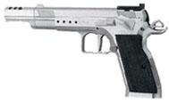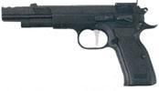
Astra Witness
Ammo | Mag | Rng | ROF | Dam | Arm
9mm P  .45 ACP | 16  10 | 18  13 | 2  2 | 1  2 | x2  x3
Astra Witness: This weapon has put EAA (European American Arms) on the map. Ease of modification and standard durability make it excellent for civilian/police use.
Nation: Spain Weight: .728 kg
Ammunition: 9mm P / .45 ACP Magazine: 16 / 10
Price: $495 Availability: ( R/S )

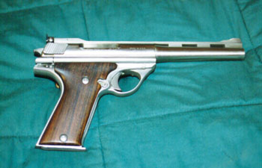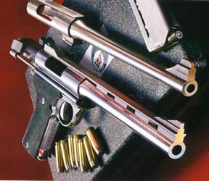
.44 Auto Mag / .357 Auto Mag
Ammo | Mag | Rng | ROF | Dam | Arm
.44 A.M.  .357 A.M. | 7  7 | 18  20 | 1  1 | 3  3 | x2  x2
Auto-Mag .44: A large caliber pistol, made famous by Clint Eastwood in the Dirty Harry films. It fires a specially designed .44 automatic magnum cartridge and has a very powerful recoil. It and it’s ammunition are extremely rare, and referees should exercise care in allowing players to have this weapon. For this reason, the weapon and its ammunition have not been assigned an availability status.
Nation: United States Weight: 1.66 kg
Ammunition: .44 / .357 AutoMag Magazine: 7
Price: $4000 Availability: ( -/- )

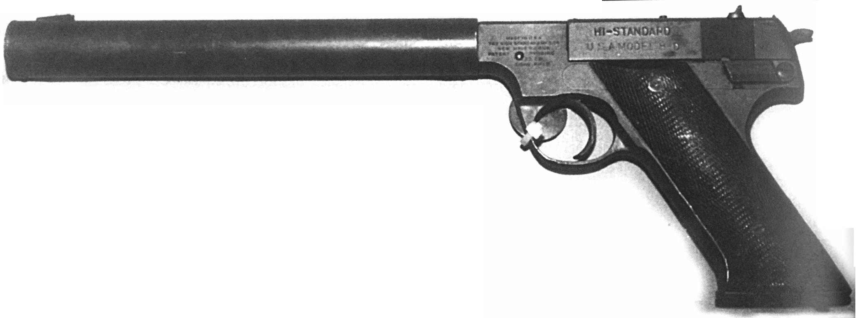
High Standard H-D .22
Ammo | Mag | Rng | ROF | Dam | Arm
.22 LR | 3 | 10 | 17 | 0 | x4
High Standard H-D .22: Originally, Hartford Arms designed the HD as a “plinking” pistol, however the HD has found its niche as an assassin’s weapon. During WW II, the OSS desired a silenced weapon for covert operations. The H-D was their pick. The H-D is very accurate and when used with a silencer/sound suppresser, the .22 LR caliber is virtually noiseless giving those around the user a –45% handicap to the Recon roll. The only drawback is that it IS, after all, only a .22.
Nation: United States Weight: .5 kg
Ammunition: .22LR Magazine: 10
Price: $300 Availability: ( R/S )

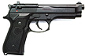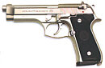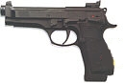
Beretta Model 92
Ammo | Mag | Rng | ROF | Dam | Arm
9mm P | 15 | 15 | 2 | 1 | x2
Beretta Model 92: A double action, modern pistol that was selected to replace the Colt M1911A1 as the standard sidearm of the US Army. Although designed in Italy, the 92S was produced in the United States as a way of ensuring a steady supply.
Nation: Italy & United States Weight: .95 kg
Ammunition: 9mm P Magazine: 15
Price: $545 Availability: ( C/S )

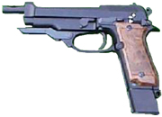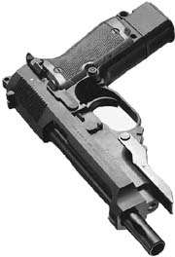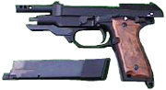

Beretta 93R
Ammo | Mag | Rng | ROF | Dam | Arm
9mm P | 15 / 25 | 15 | 2 / 2-3rnd burst | 1 | x2
Beretta 93R: The Beretta 92’s quicker little brother. The 93R has become a popular because of the fact that it has a 3-rnd burst. This weapon has been used to replace submachineguns, because it allows the same rapid fire with half the weight and size of most submachineguns. It comes with general 17 round and extended 25 round magazines.
Nation: Italy Weight: 1 kg
Ammunition: 9mm P Magazine: 15 / 25
Price: $800 Availability: ( S/S )

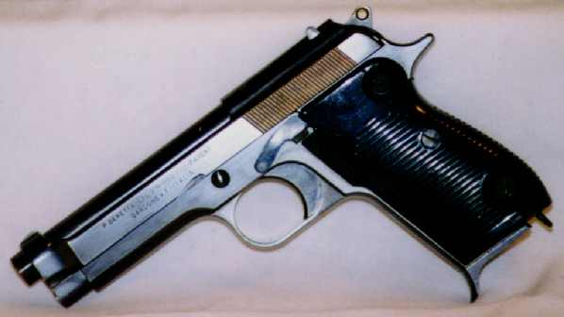
Beretta Model 951
Ammo | Mag | Rng | ROF | Dam | Arm
9mm P | 13 | 18 | 2 | 1 | x2
Beretta Model 951: The predecessor to the 92S/84 series of handguns, the M951 was designed for shooting ease and accuracy. Also known as the Beretta “Brigadier,” the M951 was the standard sidearm of the Israeli Military until its replacement in 1991 by the IMI M91.
Nation: Italy and Israel Weight: .87 kg
Ammunition: 9mm P Magazine: 13
Price: $500 Availability: ( R/S )

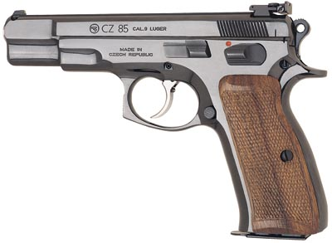
Browning BDA-380
Ammo | Mag | Rng | ROF | Dam | Arm
.380 ACP | 10 | 10 | 2 | 1 | x3
Browning BDA-380: Like the Beretta Model 84, the BDA-380 is a smaller version of a larger pistol – in this case the HP-DA. It was designed primarily for police and civilian use.
Nation: Belgium Weight: .64
Ammunition: .380 ACP Magazine: 10
Price: $350 Availability: ( C/R )

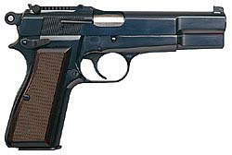
Browning Hi-Power, HP-35
Ammo | Mag | Rng | ROF | Dam | Arm
9mm P | 13 | 15 | 2 | 1 | X2
Browning Hi-Power, HP-35: One of the first commercially successful, high magazine capacity automatic pistols, the HP-35 was the last automatic pistol designed by the legendary John M. Browning. The pistol was put into production after his death, with the first ones coming off the assembly lines in the mid-1930’s. The HP-35 can be found in various nations’ arsenals. It’s reliability and production quality set the standards by which most modern automatic pistols are judged, and the HP-35 can STILL hold it’s own among all but the most advanced designs.
Nation: Belgium and Canada Weight: .9 kg
Ammunition: 9mm P Magazine: 13
Price: $535 Availability: ( C/S )

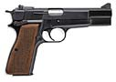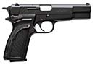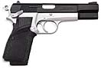
Browning Hi-Power, HP-DA
Ammo | Mag | Rng | ROF | Dam | Arm
9mm P | 13 | 15 | 2 | 1 | x2
Browning Hi-Power, HP-DA: A modernized and upgraded version of the classic HP-35, the HP-DA (Double Action) carries the fine tradition of Browning automatic pistols.
Nation: Belgium Weight: .9 kg
Ammunition: 9mm P Magazine: 13
Price: $700 Availability: ( C/R )

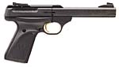
Browning Buck Mark 22
Ammo | Mag | Rng | ROF | Dam | Arm
.22 LR | 10 | 15 | 3 | 0 | x4
Browning Buck Mark 22: A high quality sporting pistol, the Mark 22 is sturdily built and designed for rugged outdoor use.
Nation: United States and Belgium Weight: .896 kg
Ammunition: .22 LR Magazine: 10
Price: $300 Availability: ( C/S )

NO PHOTO

Charter Arms Explorer II
Ammo | Mag | Rng | ROF | Dam | Arm
.22 LR | 10 | 15 | 3 | 0 | x4
Charter Arms Explorer II: An American sporting pistol, the Explorer is unique in that the magazine feed is in front of the trigger guard. An extra magazine is carried in the grip and and the barrels are interchangeable. Designed primarily for the survival market.
Nation: United States Weight: .5 kg
Ammunition: .22 LR Magazine: 10
Price: $110 Availability: ( R/R )

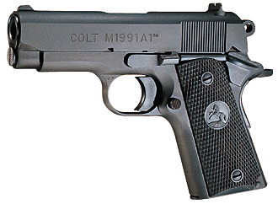
Colt Combat Commander
Ammo | Mag | Rng | ROF | Dam | Arm
.45 ACP | 7 | 10 | 2 | 2 | x3
Colt Combat Commander: Considered by many to be the definitive version of the of the M1911A1, the Combat Commander is a slightly shorter version of that classic handgun. It is often carried by US Army officers in place of the 1911.
Nation: United States Weight: 1 kg
Ammunition: .45 ACP Magazine: 8
Price: $550 Availability: ( C/S )

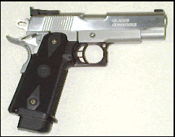
Colt Lightweight Commander
Ammo | Mag | Rng | ROF | Dam | Arm
.45 ACP | 7 (10 shown) | 10 | 2 | 2 | x3
Colt Lightweight Commander: Identical to the Combat Commander except for the aluminum frame.
Nation: United States Weight: .75 kg
Ammunition: .45 ACP Magazine: 8
Price: $550 Availability: ( C/S )

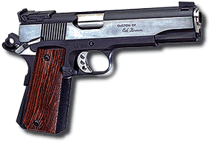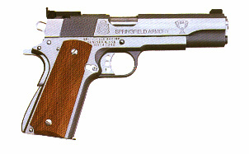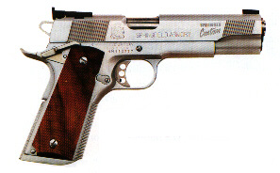
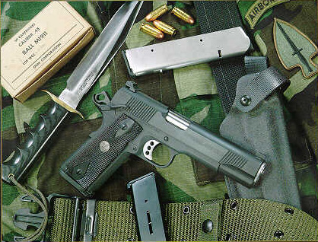
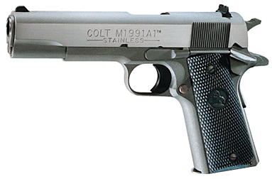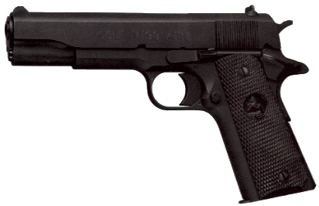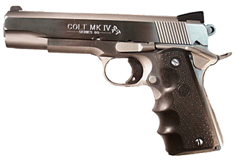
Colt M1911A1 / 1991
Ammo | Mag | Rng | ROF | Dam | Arm
.45 ACP | 8 | 10 | 2 | 2 | x3
Colt M1911A1: This weapon speaks for itself, after more than 60 years of service in the US military. Originally designed by John Browning, the M1911A1 was adopted by the US Military in 1921. It was supposed to be replaced in the late 1980’s by the Beretta 92S, but many continue to soldier on. The M1911A1 is a rugged design that has withstood the test of time (many consider it to be the finest handgun ever designed, including this guy right here).
Nation: United States Weight: 1.1 kg
Ammunition: .45 ACP Magazine: 8
Price: $650 Availability: ( C/S )

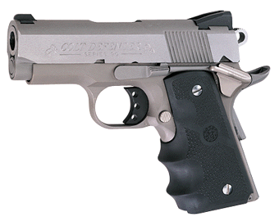
Colt Defender
Ammo | Mag | Rng | ROF | Dam | Arm
.45 ACP | 6 | 7 | 2 | 2 | x3
Colt Defender: Scaled down version of the Colt 1911 / 1991. The smaller size lessens the weapon’s accuracy, but at close ranges it is still a very effective defensive mechanism. Excellent ‘back-up’ weapon.
Nation: USA Weight: .65
Ammunition: .45 ACP Magazine: 6
Price: $500 Availability: ( C/S )

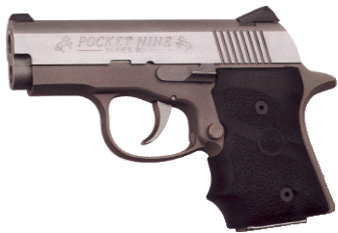
Colt “Pocket Nine” 9mm
Ammo | Mag | Rng | ROF | Dam | Arm
9mm P | 6 | 8 | 2 | 1 | x2
Colt “Pocket Nine” 9mm: Pocket Nine says it all. A palm-sized defensive ‘hold out’ pistol. Though it offers less power than the Defender, it’s smaller frame and better accuracy make this an effective back-up weapon as well.
Nation: USA Weight: .60 kg
Ammunition: 9mm P Magazine: 6
Price: $470 Availability: ( S/R )

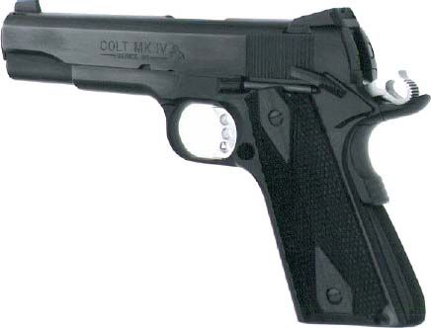
Colt Government Model .380
Ammo | Mag | Rng | ROF | Dam | Arm
.380 ACP | 6 | 10 | 2 | 1 | x3
Colt Government Model .380: Based on the M1911A1 design, the Model 380 fires the smaller .380 ACP round. It is designed for the civilian and police market.
Nation: United States Weight: 1 kg
Ammunition: .380 ACP Magazine: 8
Price: $375 Availability: ( S/R )

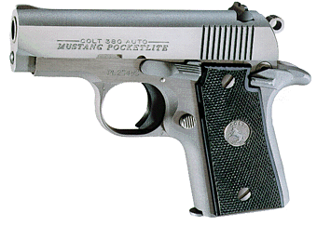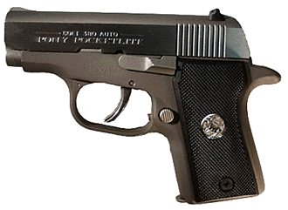
Colt Mustang / Pony
Ammo | Mag | Rng | ROF | Dam | Arm
.380 ACP  .380 ACP | 6  6 | 10  8 | 2  2 | 1  1 | x3  x3
Colt Mustang / Pony: These two are the GM .380’s little brothers. Accuracy and concealability make them effective hold outs.
Nation: USA Weight: .60 / .55 kg
Ammunition: .380 ACP Magazine: 6
Price: $450 / $450 Availability: ( S/R )

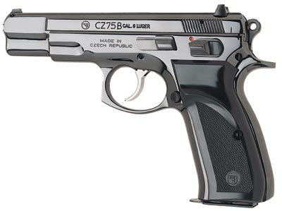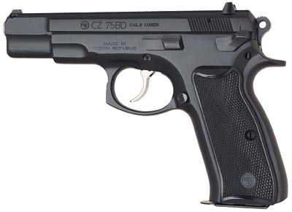
Czech CZ-75
Ammo | Mag | Rng | ROF | Dam | Arm
9mm P  .40 | 10  10 | 15  10 | 2  2 | 1  2 | x2  x3
Czech CZ-75: An upgrade of earlier Czechoslovakian pistols, the CZ-75 was designed with the Western Market in mind. It was much sought after, although it was difficult to obtain in the United States.
Nation: Czechoslovakia Weight: .9 kg
Ammunition: 9mm P Magazine: 8
Price: $550 Availability: ( S/C )

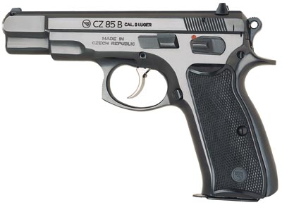
Czech CZ-85
Ammo | Mag | Rng | ROF | Dam | Arm
9mm P  .40 | 10  10 | 15  10 | 2  2 | 1  2 | x2  x3
Czech CZ-85: Due to the popularity of the CZ-75, the CZ-85 was introduced. The same quality and respectability as the CZ-75, with enhanced safety features and newer design.
Nation: Czechoslovakia Weight: .8 kg
Ammunition: 9mm P / .40 Magazine: 10 / 10
Price: $650 / $675 Availability: ( S/C )

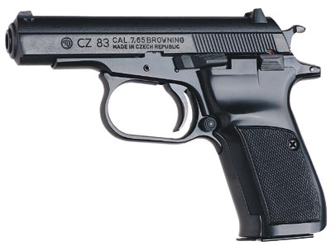
Czech CZ-83
Ammo | Mag | Rng | ROF | Dam | Arm
.380 ACP  9mm P | 10  8 | 8  12 | 2  2 | 1  1 | x3  x2
Czech CZ-83: The compact of Czechoslovakia. This lightweight compact is very easily concealed. The small calibers make the magazines easy to conceal as well.
Nation: Czechoslovakia Weight: .55 / .60 kg
Ammunition: .380 ACP / 9mm P Magazine: 10 / 8
Price: $350 / $420 Availability: ( S/C )

